**DAILY ONLINE ACTIVITIES SUMMARY**

|  |  |  |  |  |  |  |  |  |
| --- | --- | --- | --- | --- | --- | --- | --- | --- |
| **Date:** | **18-05-2020** | | | | | **Name:** | **Rohan Mahaveer** | |
| **Sem & Sec** | **6th B** | | | | | **USN:** | **4AL17CS077** | |
| **Online Test Summary** | | | | | | | | |
| **Subject** | | **Cryptography Network Security & Cyber Laws (CNSC)** | | | | | | |
| **Max. Marks** | | **60** | | **Score** | | | **40** | |
| **Certification Course Summary** | | | | | | | | |
| **Course** | **Ethical Hacking** | | | | | | | |
| **Certificate Provider** | | | **Alison** | | **Duration** | | | **6hrs** |
| **Coding Challenges** | | | | | | | | |
| 1. Problem Statement: 1. Using methods charAt() & length() of String class, write a program to print the frequency of each character in a string.“Hello friend”.Output should be.-: 1,d: 1,e: **2,**f: 1, (continued for all character in the string) 2. 2. Write down a java program to print even and odd numbers series respectively from two threads: t1 and t2 synchronizing on a shared objectLet t1 print message “ping — >” and t2 print message “,—-pong”.Take as command line arguments, the following inputs to the program: Sleep Interval for thread t1 Write down a java program to print even and odd numbers series respectively from two threads: t1 and t2 synchronizing on a shared object | | | | | | | | |
| **Status:** YES, Completed all Programs | | | | | | | | |
| **Uploaded the report in Github** | | | | | **YES** | | | |
| **If yes Repository name** | | | | | <https://github.com/rohanmahaveer/daily-status> | | | |
| **Uploaded the report in slack** | | | | | **YES** | | | |

Online Test Details: (Attach the snapshot and briefly write the report for the same)

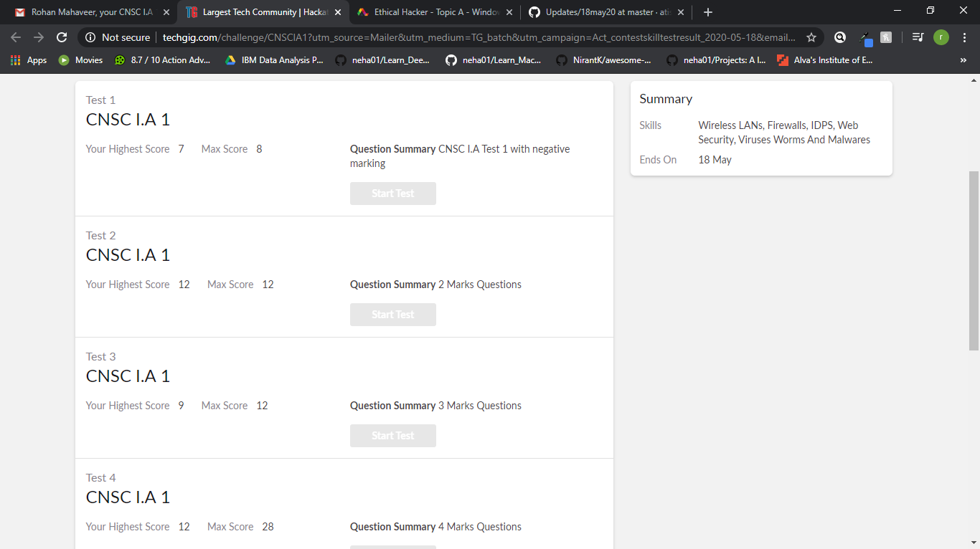

Scored 40 out of 60 in CGV 1st I.A test

Certification Course Details: (Attach the snapshot and briefly write the report for the same)

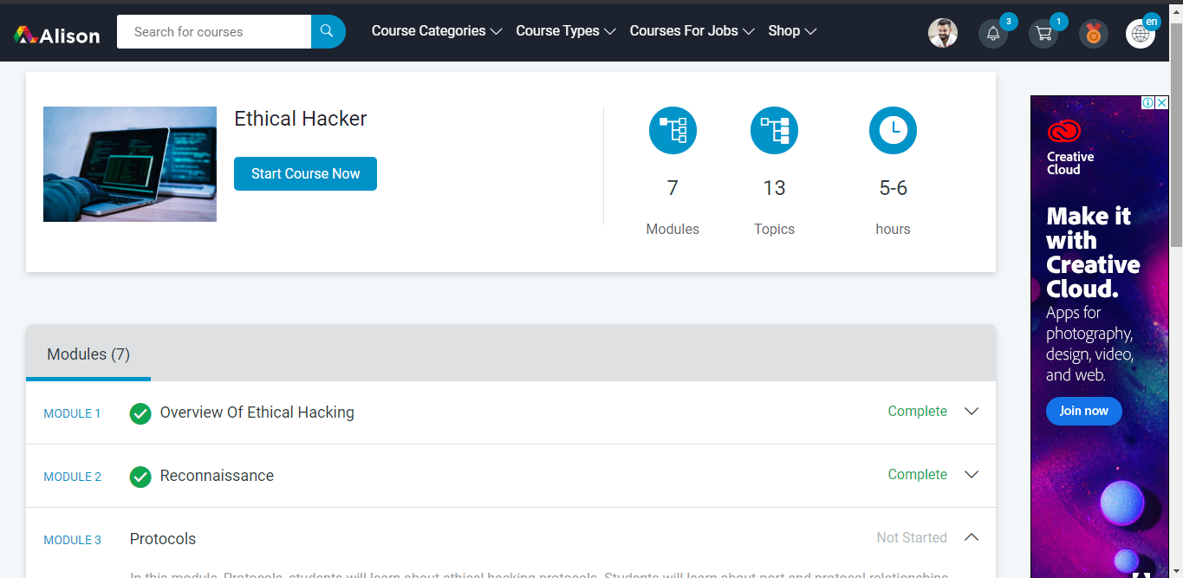

The above course is being taken up by me is based on Ethical hacking. It started with the CIA triad, today in online course I studied about the overview of the ethical hacking and the first in the hacking phase that is reconnaissance. The details of the course and certificate provider are mentioned in the above form.

Coding Challenges Details: (Attach the snapshot and briefly write the report for the same)

Program1:

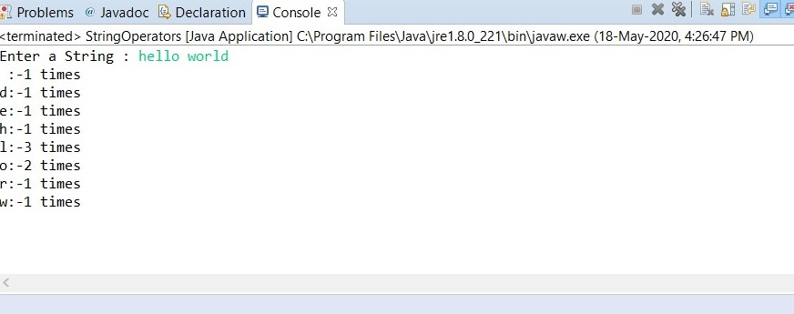

Program2:

